Set 7 - Assignments on TSQL

All the questions from this set are based on the default emp and dept tables. The screenshots of expected outputs are of some other database editor. So, in SSMS the output’s format, look & feel will differ.
For the first 10 questions you are free to use any SQL technique such as Inbuilt SQL functions, Group By, Having, Aggregate Functions, Joins, Sub Queries, Set Operators, Derived Tables, Window Functions, looping, cursors, stored procedure, user defined functions, etc.

- Create the following type of Deptno-wise Sub Total report.

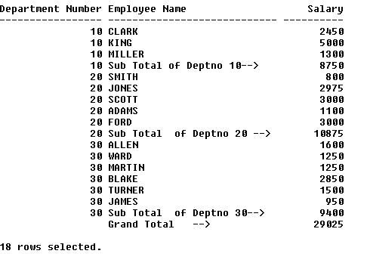

select DEPTNO as "Department Number", ENAME, SAL from EMP
where DEPTNO = 10
union
select DEPTNO,'Sub total of Deptno '+cast(DEPTNO as varchar)+'-->',sum(sal) from EMP
where DEPTNO = 10
group by DEPTNO
union
select DEPTNO as "Department Number", ENAME, SAL from EMP
where DEPTNO = 20
union
select DEPTNO,'Sub total of Deptno '+cast(DEPTNO as varchar)+'-->',sum(sal) from EMP
where DEPTNO = 20
group by DEPTNO
union
select DEPTNO as "Department Number", ENAME, SAL from EMP
where DEPTNO = 30
union
select DEPTNO,'Sub total of Deptno '+cast(DEPTNO as varchar)+'-->',sum(sal) from EMP
where DEPTNO = 30
group by DEPTNO
UNION
SELECT NULL,'grand total',SUM(SAL) FROM EMP

2) Create the following type of Department-Job Sub Total report –

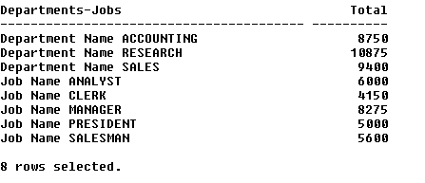

select 'Department Name '+d.DNAME as "Department-Job", sum(e.SAL) as "Total"
from emp e, dept d
WHERE E.DEPTNO = D.DEPTNO
GROUP BY D.DNAME
UNION
select 'Job Name '+JOB, SUM(SAL)
from emp
GROUP BY JOB

3) Create the following sub-totals of year-wise salary details.

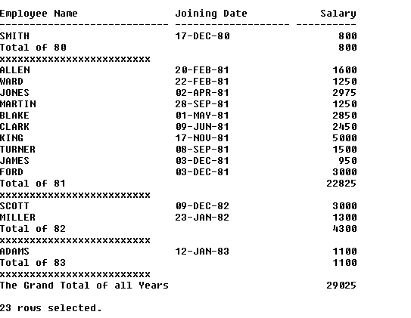

(select ENAME as "Employee Name", convert(varchar, HIREDATE, 6) as "Joining Date", cast(SAL as varchar) as "Salary"
from EMP
where year(HIREDATE) = 1980
union all
select 'Total of 80',' ',cast(sum(SAL) over() as varchar)from EMP
where year(HIREDATE) = 1980
union all
select '****************************', ' ',' ')
union all
(select ENAME as "Employee Name", convert(varchar, HIREDATE, 6) as "Joining Date", cast(SAL as varchar) as "Salary"
from EMP
where year(HIREDATE) = 1981
union all
select 'Total of 81' ,' ',cast(sum(SAL) as varchar)from EMP
where year(HIREDATE) = 1981
union all
select '****************************', ' ',' ')
union all
(select ENAME as "Employee Name", convert(varchar, HIREDATE, 6) as "Joining Date", cast(SAL as varchar) as "Salary"
from EMP
where year(HIREDATE) = 1982
union all
select 'Total of 82' ,' ',cast(sum(SAL) as varchar)from EMP
where year(HIREDATE) = 1982
union all
select '****************************', ' ',' ')
UNION ALL
(select ENAME as "Employee Name", convert(varchar, HIREDATE, 6) as "Joining Date", cast(SAL as varchar) as "Salary"
from EMP
where year(HIREDATE) = 1983
union all
select 'Total of 83' ,' ',cast(sum(SAL) as varchar)from EMP
where year(HIREDATE) = 1983
union all
select '****************************', ' ',' ')
UNION ALL
select 'Grand total of all years' ,' ',cast(sum(SAL) as varchar)from EMP

4) Display the deptno-wise employees with the record of the lowest earner in each deptno as shown below.

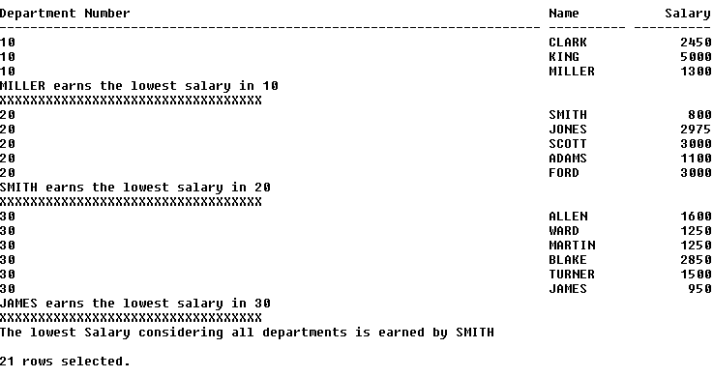
(select distinct cast(DEPTNO as varchar) as 'Department Number',ENAME as 'name',cast(SAL as varchar) as 'Salary'
from emp
where DEPTNO = 10
union all
select distinct concat(ename ,' earns the lowest salary in ',DEPTNO) as 'Department Number', ename as 'name', cast(min(sal) over(partition by deptno) as varchar )as Salary
from emp
where DEPTNO = 10
and SAl = (select min(SAL) from emp where DEPTNO = 10)
UNION all
select 'XXXXXXXXXXXXXXXXXXXXXXX', ' ', ' ' )

union all

(select distinct cast(DEPTNO as varchar) as 'Department Number',ENAME as 'name',cast(SAL as varchar) as 'Salary'
from emp
where DEPTNO = 20
union all
select distinct concat(ename ,' earns the lowest salary in ',DEPTNO) as 'Department Number', ename as 'name', cast(min(sal) over(partition by deptno) as varchar )as Salary
from emp
where DEPTNO = 20
and SAl = (select min(SAL) from emp where DEPTNO = 20)
UNION all
select 'XXXXXXXXXXXXXXXXXXXXXXX', ' ', ' ')

union all

(select distinct cast(DEPTNO as varchar) as 'Department Number',ENAME as 'name',cast(SAL as varchar) as 'Salary'
from emp
where DEPTNO = 30
union all
select distinct concat(ename ,' earns the lowest salary in ',DEPTNO) as 'Department Number', ename as 'name', cast(min(sal) over(partition by deptno) as varchar )as Salary
from emp
where DEPTNO = 30
and SAl = (select min(SAL) from emp where DEPTNO = 30)
UNION all
select 'XXXXXXXXXXXXXXXXXXXXXXX', ' ', ' ')

union all

SELECT 'The lowest salary considering all departments is earned by '+ename ,' ', ' '
from emp
where sal= (select min(SAL) from emp)

5) Display the highest two salary records within each job as shown below --

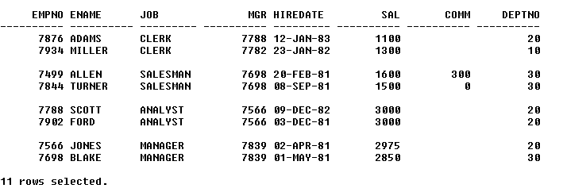

with JobWise_Rank as(
select *, dense_rank() over(Partition by job order by SAL DESC) as "EMP_RANK"
from emp
where MGR is not NULL)
select CAST(EMPNO AS varchar), ENAME, JOB, CAST(MGR AS VARCHAR), convert(varchar, HIREDATE,6) as "HireDate", SAL, isnull(cast(COMM as varchar),' ') as "Comm",cast(DEPTNO as varchar) from JobWise_Rank
where EMP_RANK <= 2 and job = 'Clerk'
union all
select '','','','','','','',''
UNION ALL
select CAST(EMPNO AS varchar), ENAME, JOB, CAST(MGR AS VARCHAR), convert(varchar, HIREDATE,6) as "HireDate", SAL, isnull(cast(COMM as varchar),' ') as "Comm",cast(DEPTNO as varchar) from JobWise_Rank
where EMP_RANK <= 2 and job = 'SALESMAN'
union all
select '','','','','','','',''
UNION ALL
select CAST(EMPNO AS varchar), ENAME, JOB, CAST(MGR AS VARCHAR), convert(varchar, HIREDATE,6) as "HireDate", SAL, isnull(cast(COMM as varchar),' ') as "Comm",cast(DEPTNO as varchar) from JobWise_Rank
where EMP_RANK <= 2 and job = 'analyst'
union all
select '','','','','','','',''
UNION ALL
select CAST(EMPNO AS varchar), ENAME, JOB, CAST(MGR AS VARCHAR), convert(varchar, HIREDATE,6) as "HireDate", SAL, isnull(cast(COMM as varchar),' ') as "Comm",cast(DEPTNO as varchar) from JobWise_Rank
where EMP_RANK <= 2 and job = 'manager'

6) Display the records sorted as per deptno along –with the record of the oldest employee within that deptno as shown below --

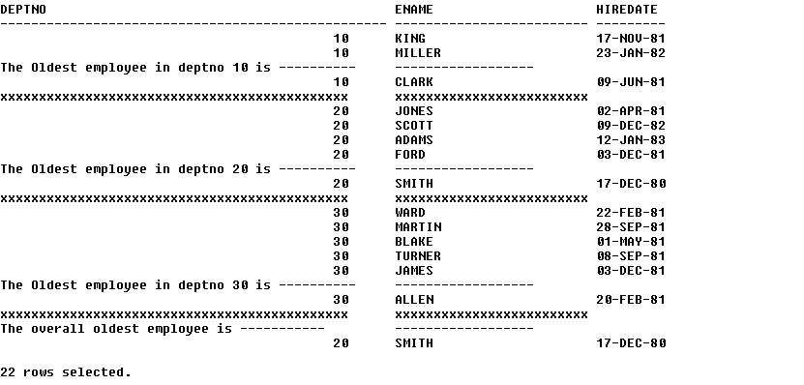

(select cast(DEPTNO as varchar), ENAME, convert(varchar, HIREDATE,6) from EMP
where DEPTNO = 10 and HIREDATE != (select min(HIREDATE) from EMP where DEPTNO = 10)
union all
select 'The oldest employee in the deptno 10 is---------','--------------',''
union all
select top 1 cast(deptno as varchar), ENAME , convert(varchar, HIREDATE,6)
from EMP
where DEPTNO = 10
union all
select 'XXXXXXXXXXXXXXXXXXXXXXXXXXXXXXXXXXXXXXXXXXX','XXXXXXXXXXXX', ' ')

union all
(select cast(DEPTNO as varchar), ENAME, convert(varchar, HIREDATE,6) from EMP
where DEPTNO = 20 and HIREDATE != (select min(HIREDATE) from EMP where DEPTNO = 20)
union all
select 'The oldest employee in the deptno 10 is---------','--------------',''
union all
select top 1 cast(deptno as varchar), ENAME , convert(varchar, HIREDATE,6)
from EMP
where DEPTNO = 20
union all
select 'XXXXXXXXXXXXXXXXXXXXXXXXXXXXXXXXXXXXXXXXXXX','XXXXXXXXXXXX', ' ')

union all
(select cast(DEPTNO as varchar), ENAME, convert(varchar, HIREDATE,6) from EMP
where DEPTNO = 30 and HIREDATE != (select min(HIREDATE) from EMP where DEPTNO = 30)
union all
select 'The oldest employee in the deptno 10 is---------','--------------',''
union all
select top 1 cast(deptno as varchar), ENAME , convert(varchar, HIREDATE,6)
from EMP
where DEPTNO = 30
union all
select 'XXXXXXXXXXXXXXXXXXXXXXXXXXXXXXXXXXXXXXXXXXX','XXXXXXXXXXXX', ' ')

union all
select 'The overall oldest employee is---------','--------------',''
union all
select top 1 cast(deptno as varchar), ENAME , convert(varchar, HIREDATE,6)
from EMP
7) Display the employees earning less than the average salary of their own jobs as shown below --

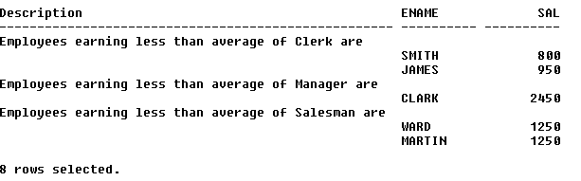

select 'Employees earning less than average of Clerk are',' ' as ENAME,' ' as SAL
UNION all
select ' ', ENAME, CAST(SAL AS varchar)
from EMP
where JOB = 'clerk'
AND SAL < (select AVG(SAL)
from EMP
where JOB = 'clerk')
UNION all
select 'Employees earning less than average of MANAGER are',' ' as ENAME,' ' as SAL
UNION all
select ' ', ENAME, CAST(SAL AS varchar)
from EMP
where JOB = 'MANAGER'
AND SAL < (select AVG(SAL)
from EMP
where JOB = 'MANAGER')
UNION all
select 'Employees earning less than average of Salesman are',' ' as ENAME,' ' as SAL
UNION all
select ' ', ENAME, CAST(SAL AS varchar)
from EMP
where JOB = 'Salesman'
AND SAL < (select AVG(SAL)
from EMP
where JOB = 'Salesman')

8) Create the following Master-Detail type of report

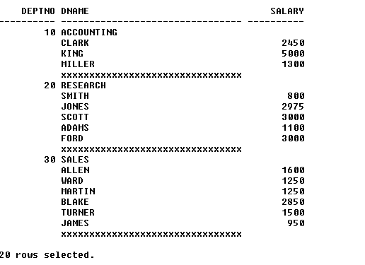

(select cast(DEPTNO as varchar), DNAME, '' as "Salary" from DEPT where DEPTNO = 10
union all
select '', ENAME, cast(SAL as varchar) from EMP where DEPTNO = 10
UNION ALL
select '','XXXXXXXXXXXXXXXXXXXXXXXXXX','')
union all
(select cast(DEPTNO as varchar), DNAME, '' as "Salary" from DEPT where DEPTNO = 20
union all
select '', ENAME, cast(SAL as varchar) from EMP where DEPTNO = 20
UNION ALL
select '','XXXXXXXXXXXXXXXXXXXXXXXXXX','')
union all
(select cast(DEPTNO as varchar), DNAME, '' as "Salary" from DEPT where DEPTNO = 30
union all
select '', ENAME, cast(SAL as varchar) from EMP where DEPTNO = 30
UNION ALL
select '','XXXXXXXXXXXXXXXXXXXXXXXXXX','')

9) Create the following Master-Detail Summary type of report.

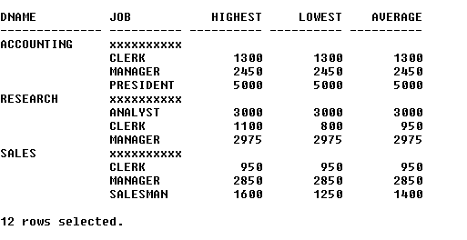

(select 'Accounting', 'XXXXXXXXXX' as "JOB", '' as "Highest", '' as "Lowest",'' as "Average"
union all
select '',E.JOB, CAST(max(E.SAL) AS varchar), CAST(min(E.SAL) AS varchar), CAST(avg(E.SAL) AS varchar) from EMP E join DEPT D
on E.DEPTNO =D.DEPTNO
where DNAME = 'Accounting'
group by E.JOB,D.DEPTNO)
UNION ALL
(select 'RESEARCH', 'XXXXXXXXXX' as "JOB", '' as "Highest", '' as "Lowest",'' as "Average"
union all
select '',E.JOB, CAST(max(E.SAL) AS varchar), CAST(min(E.SAL) AS varchar), CAST(avg(E.SAL) AS varchar) from EMP E join DEPT D
on E.DEPTNO =D.DEPTNO
where DNAME = 'RESEARCH'
group by E.JOB,D.DEPTNO)
UNION ALL
(select 'SALES', 'XXXXXXXXXX' as "JOB", '' as "Highest", '' as "Lowest",'' as "Average"
union all
select '',E.JOB, CAST(max(E.SAL) AS varchar), CAST(min(E.SAL) AS varchar), CAST(avg(E.SAL) AS varchar) from EMP E join DEPT D
on E.DEPTNO =D.DEPTNO
where DNAME = 'SALES'
group by E.JOB,D.DEPTNO)
10) Create the Organization hierarchy report as shown below –

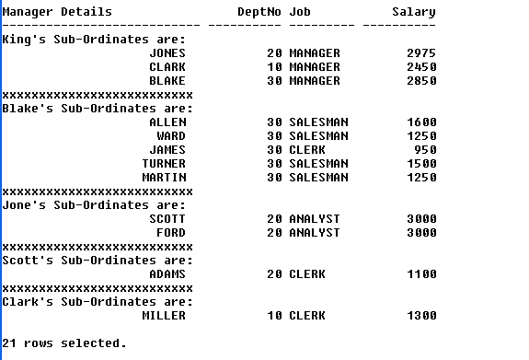

(select 'King''s Sub-Ordinates are: ' as "Manager Details", '' as "DeptNO", '' as "Job", '' as "Salary"
union all
select ENAME, cast(DEPTNO as varchar), cast(JOB as varchar), cast(SAL as varchar) from EMP where MGR = (select EMPNO from EMP where ENAME = 'KING')
union all
select 'XXXXXXXXXXXXXXXXXXXXXXXXXXX' ,'','','')
union all
(select 'Blake''s Sub-Ordinates are: ' as "Manager Details", '' as "DeptNO", '' as "Job", '' as "Salary"
union all
select ENAME, cast(DEPTNO as varchar), cast(JOB as varchar), cast(SAL as varchar) from EMP where MGR = (select EMPNO from EMP where ENAME = 'Blake')
union all
select 'XXXXXXXXXXXXXXXXXXXXXXXXXXX' ,'','','')
union all
(select 'Scott''s Sub-Ordinates are: ' as "Manager Details", '' as "DeptNO", '' as "Job", '' as "Salary"
union all
select ENAME, cast(DEPTNO as varchar), cast(JOB as varchar), cast(SAL as varchar) from EMP where MGR = (select EMPNO from EMP where ENAME = 'Scott')
union all
select 'XXXXXXXXXXXXXXXXXXXXXXXXXXX' ,'','','')
union all
(select 'Jones''s Sub-Ordinates are: ' as "Manager Details", '' as "DeptNO", '' as "Job", '' as "Salary"
union all
select ENAME, cast(DEPTNO as varchar), cast(JOB as varchar), cast(SAL as varchar) from EMP where MGR = (select EMPNO from EMP where ENAME = 'Jones')
union all
select 'XXXXXXXXXXXXXXXXXXXXXXXXXXX' ,'','','')
union all
(select 'Clark''s Sub-Ordinates are: ' as "Manager Details", '' as "DeptNO", '' as "Job", '' as "Salary"
union all
select ENAME, cast(DEPTNO as varchar), cast(JOB as varchar), cast(SAL as varchar) from EMP where MGR = (select EMPNO from EMP where ENAME = 'Clark'))

Question 11, 12 and 13 should be solved only using the technique of Correlated Sub Queries.

11) Display the highest two salary values from emp table.
SELECT TOP 2 sal
FROM EMP
where SAL in (SELECT DISTINCT TOP 2 sal
FROM emp
ORDER BY sal DESC)
ORDER BY sal desc

12) Display the fourth lowest salary value from emp table.
--q12
SELECT TOP 1 sal
FROM EMP
where SAL in (SELECT DISTINCT TOP 4 sal
FROM emp
ORDER BY sal ASC)
ORDER BY sal desc

13) Display the record (s) of employees who earn the second highest salary in each deptno from emp table.
SELECT top 2 *
FROM EMP
where SAL in (SELECT TOP 3 sal
FROM emp
ORDER BY sal desc)
ORDER BY sal

